Now in this lesson we are going to learn how to use styles with buttons and in the last of the lesson you will see a good looking output where we will make lots of buttons whom we will make different colors. We will give margin padding border radius how to give shadows and we will learn a lot

One thing you need to keep in mind that is even asked in interviews as well that in the default button of React native

0:22

We cannot apply too much style on i. It ahs some limitation It can take only some props for style because it is made for basic thing whenever you want ot make a stylish button tehn you have two component option one id Touchable Highlight which we will see in this lesson and second is Touchable Opacity whatever component you use they are completely similar the even thing is also similar here but you get flexibility here such that you apply styles here as compared to normal button

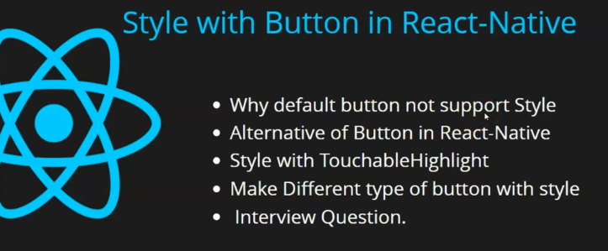

In points as the teacher has already said that defaulkt button does not support too much style that’s why we need alternative that is Touchable highlight and Touchable Opaque you can even tell it in Interviews that what are the alternative of buttons and then we go to code so that we see how we apply styles and how to use Touchable Opacity.

Now in App.jsx we have simple code as shown below

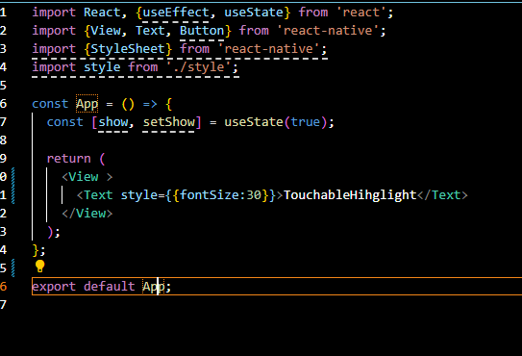

There is nothing special here

Now import Touchable Highlight here from react-native library. Now we remove the Text component. Now Teacher is showing us from scratch .Now if you directly use it then it will show us errors

So the code will be like below

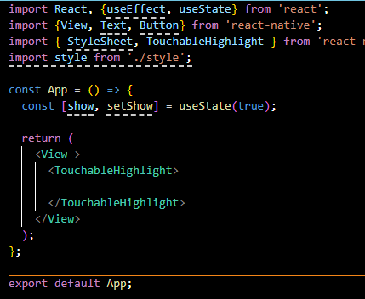

Now output will show an error like below

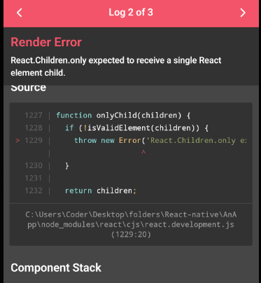

It is saying that there should be child in TouchableHighlight component on which you can apply styles here so we write text here and we place “Button : in between Text components. Now our design code will look like below

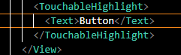

IN output you will like this as marked below

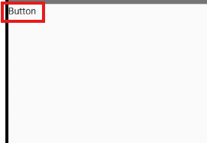

The default Button we import from react native it is very different from it

You might have remembered that in normal button ther is not text component ior any other component in between button components we just used title attribute here

It will look good like below



But it is for appearance as by default style is applied on it (Teacher say it UI) and we have not applied style in Touchable Highlight

If you perform events here then they both works same there will be no major difference. Now how to give good style to the TouchableHighlight. Now we import Stylesheet now because Teacher would like to use styles separately. As he does not like in line. By using inline your reusability is reduced

Now we add a stylesheet and add main property having property flex:1 And we add this main property to top view so that it can work properly it don’t have any purpose if you even don’t add it then it will work Now we will see how to add style to Touchable highlight or opacity you don’t need to apply styles on the button but you need to apply on the component inside it. In this case Text

We add “button” property to the styles that give background color that is grey color

Now our style will look like below

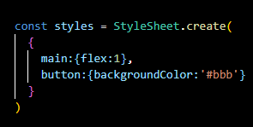

Now our designer code will look like below

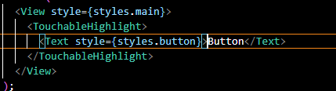

The output will be like below

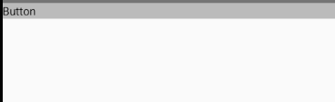

But it is not looking that good we fix it more and add a color property of value white to the button property of style we also add font size property to the button property of value 24. We add text align to the button and give it value of center to align the text in the centre in the button. We add padding of 10 to the button property also add margin of 10

Now styles will look like below

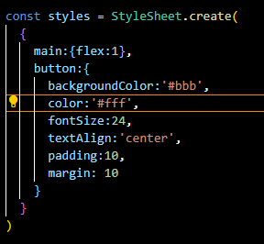

And now it will look like somewhat a button now in the output



5:45

Now we give the border radius property button property to the button property in styles

We give it 10 and now it look shown below in the code

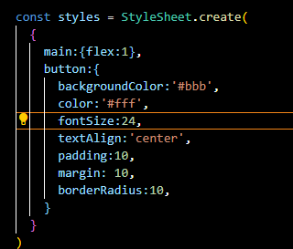

Now our button in output look like below

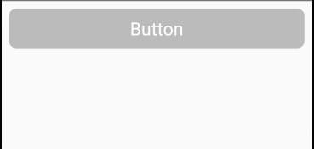

Now you can see it is rounded from corner as shown above

Now we add shadow to our button by modifying button property of the style

SO we add shadowColor It tells the color of the shadow that will be formed Teacher make it red but it will be changed later you will not see any changes in your output as it need other property that is elevation. It simulate how much the button is above the screen. We give it 10

Now our code will look like below

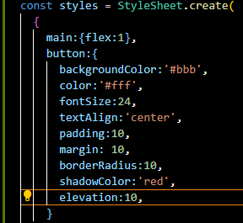

**Output**

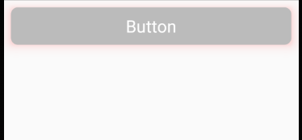

Now you can see outline is slightly red in color.

And then here is opacity parameter here we can set it to 1 for full opacity and set less than 1 for less opacity.for full opacity the output will be like above

Now our code will look like below

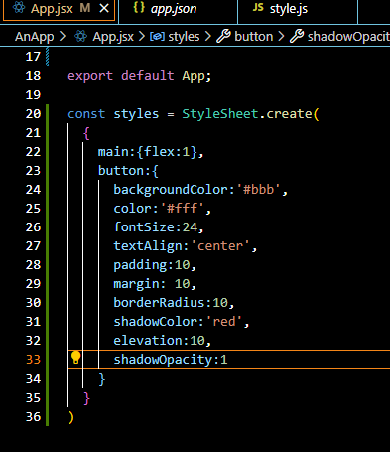

Now we made one button and it is a common button. Now Teacher want to make different button here. Like we want make a button for success like on the basis of success of something we want to submit(who knows).

So we add a duplicate out button Now our design code will be like below

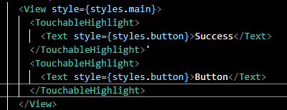

Now our output will be like below

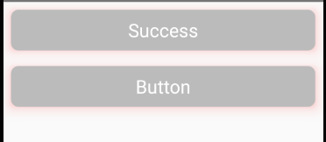

We add another property in style for Success button and we name it success

**Discovery:-**

When we add more than one style to the component by passing array in {} of style then all of them and the last one style overrides the previous one styles

So we add button style property and then add success also

Now our style property will look like below

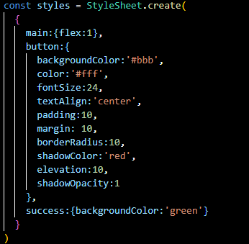

Now our design code will look like below

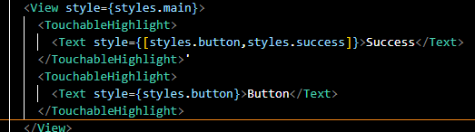

Now our output will look like below

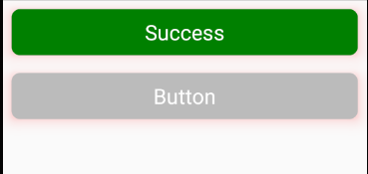

Now we make a primary button

So we add a primary button so we add a new property called primary and there set it to background blue color

Now our style code look like below

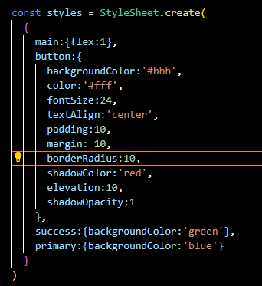

Now our design code will look like below

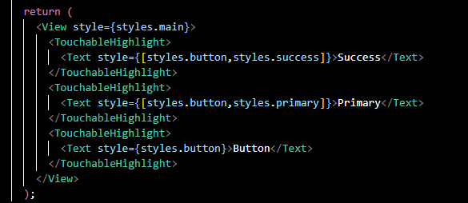

Now our output will look like below

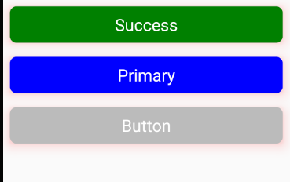

Now we can make a button for Warning and Error

Now our style has error for red background and warning property for gold background as shown below

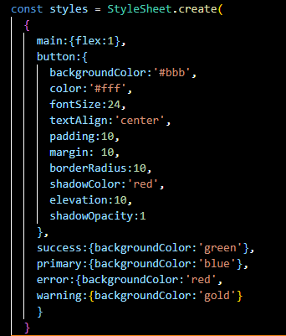

Now our design code will look like below

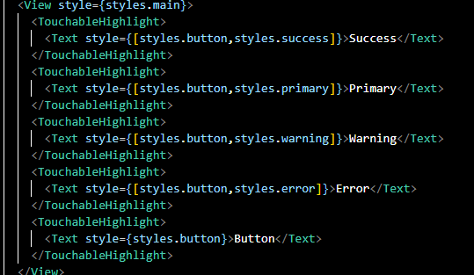

Now our output will look like below

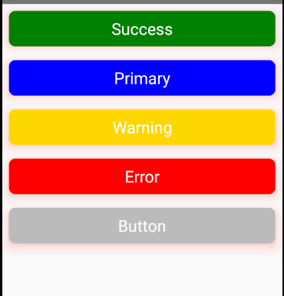

9:50

SO if you want to make a colored buttons then you can make it very easily but by this way you get a basic idea that you make a button property in styles that is for the buttons and then make alternate property for overriding a button color. In css we call it class but here we call it objects or properties here So by this way you can make different buttons here. In next lesson we will see how to make radio buttons and there is a thing called swich which we will see we upcoming of switch and of status bar and three – four lesson will come on style so that you can do style perfectly.

And then we will start API or routing that’s all for this lesson.